The Resource Exchange Evaluation of the Effectiveness of the
Family Supports and Services Program
for
FY 2019-2020

The Resource Exchange’s FSSP Program served 485 individuals during Fiscal Year 2019-2020. Individuals ages 3-66 were served during this fiscal year. The chart below compares the age of participants within the TRE FSSP Program to the population in each of counties in TRE’s catchment area. Most of the individuals served were under the age of 23 (92%). The decline in numbers served after the age of 23 is primarily related to availability of and access to Adult HCBS supports.

Data compiled from the Colorado Springs Chamber of Commerce for Colorado Springs, El Paso and Teller Counties, November 2019. Date complied for Park County from suburbanstats.org.

As shown in the next chart, the distribution of race and ethnicity of FSSP participants during Fiscal Year 2017-2018 averaged comparatively with that of the catchment areas served.

Data compiled from the Colorado Springs Chamber of Commerce for Colorado Springs, El Paso and Teller Counties, November 2019. Data complied for Park County from suburbanstats.org.

As shown in the chart below 55% of the individuals served by FSSP in FY 2019-20 had an Autism diagnosis. Down Syndrome, Cerebral Palsy and Developmental Disability were the next most prevalent diagnoses among FSSP participants.

TRE FSSP invests heavily in partnerships with a variety of community agencies, programs, and services. These partnerships allow Family Support Coordinators to inform families of resources and assist in the connections to these resources based on family priorities. These partnerships include:
- Educational Supports - The Arc of the Pikes Peak Region and the Peak Parent Center
- Guardianship and Other Advocacy - The Arc of the Pikes Peak Region
- Transition Supports and IEP Needs – 17 School Districts across El Paso, Park and Teller counties and the Pikes Peak Inter Agency Transition team.
- Medical Needs and Supports – Community Health Care Alliance (RAE) and El Paso County Department of Health, HCP Program
- Mental Health Needs and Supports – Community Health Care Alliance (RAE), Aspen Pointe and a variety of community behavioral and mental health care providers.
- Departments of Human Services and the Collaborative Management Program (CMP) in all 3 counties
- Park and Teller County Collaborations - Community Partnership Family Resource Center (Teller) and Mountain Resource Center (Park). Teller and Park counties FSSP Staff also work very closely with local DHS offices, and the Collaborative Management Program (CMP) – HB 1451 group.
- Recreation and Physical Health - YMCA of the Pikes Peak Region, City of Colorado Springs Therapeutic Recreation Program, Special Olympics, and Tae Kwon Do.

TRE FSSP has responded to feedback from families and the FSSP Council in creating a variety of activities that benefit multiple families within the FSSP program and other TRE departments.
- In 2015 a Resource Navigation Position was created to coordinate and manage a database of local resources in order to enhance access for families and service coordinators to information and improve connections for families in times of need. The database is maintained and accessible on the TRE website and updated regularly. The Resource Navigator is also available to families to answer any questions regarding resources and assist families in locating resources for more specific needs including those families on the waiting list.
- Family Support Staff also sit on The Pikes Peak Interagency Transition Team to stay abreast of specific community resources to meet the needs of the transition aged individuals served by FSSP.
- Break Time Respite Program has been operated at TRE for more than 15 years, providing respite opportunities to families of children 3 months to 21 years of age with special needs/developmental disabilities and their sibling’s. The program is staffed by a Coordinator, Behavior Specialist, Nurse, and community volunteers and is supplemented with grant funding. The Break Time Coordinator has engaged many community partners such as The United States Air Force Academy; University of Colorado, Colorado Springs Bethel College of Nursing; Colorado College Education Department; and Pikes Peak Community College Early Education Department; El Paso County Sherriff’s Office; Colorado Springs Police Department; Colorado Springs Fire Department to build a pool of volunteers matched one-on-one with children attending to ensure a fun and safe experience for all. Average participation per session is 25-40 children. Break Time is held 3 times per month but is currently on hiatus due to the COVID 19 Pandemic.
- Positive Solutions for Family (PSFF) is a 7-week training to assist parents of children up to 8 years of age in developing positive social and emotional skills for their children and to assist parents in understanding problem behaviors and in developing strategies to manage those behaviors. This program is a partnership with local churches, the early childhood council, Lutheran Family Services, and other community agencies and is delivered 6-8 times per year. Average attendance is 20-40 parents. 32 families participated in PSFF last fiscal year. This year the sessions will be offered virtually in response to the COVID19 Pandemic.

In the spring of 2020 TRE conducted Customer Satisfaction Surveys with families enrolled at that time. Surveys were sent to all enrolled families. 83 responded the survey. The results provided below indicate an overwhelming strong satisfaction of families with the services they received through FSSP. In addition, this information has contributed to program development and ongoing improvement.
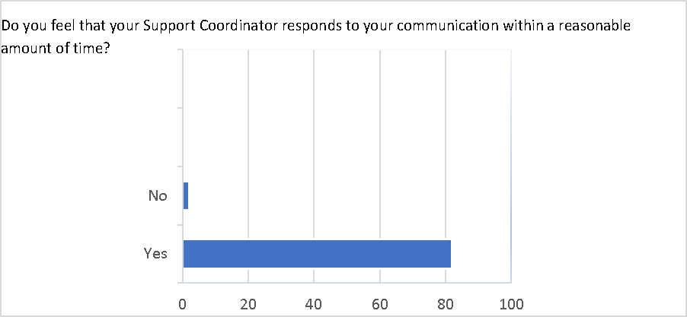

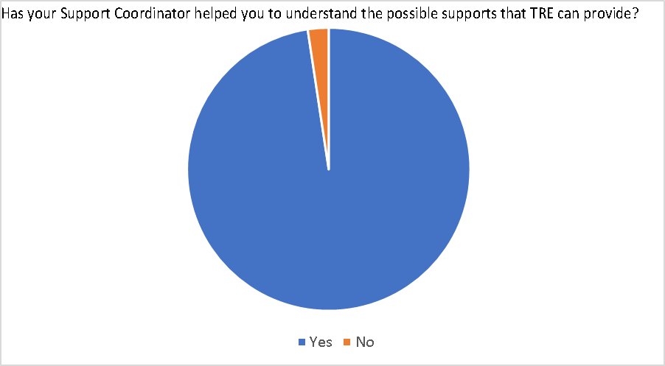

Educational Advocacy as well as job supports were area of support frequently requested by families, especially as their family member entered the period of transition from high school to adult life. In response the FSSP team has participated in further training regarding IEPs and available job supports in the community.

The final question of the survey asked is there anything else you want your Family Support Coordinator to know? The responses to this question demonstrated both the tremendous gratitude and satisfaction families have for the Family Support Program. Those responses included the following:
- You make a real difference in our lives!
- She is a true blessing in helping my family and I, with services. We are so grateful that she is over my son case.
- She is a constant for us in a sea of infinite change. She is supportive and always does her best to help us meet our needs.
- I have been so pleased with the support, it feels so wonderful to finally feel like there is an ally in my advocating for my son, the relief in that is just amazing!!
- We appreciate all your support to our family we very blessed to have this program from our daughter.

TRE’s Family Support Council has prioritized the need for case coordination and support for the families we serve and ongoing assistance in helping connect families to the resources they need in the community above and beyond the defined case management activities of the program. To that effort Family Support Coordinators worked to identify and connect families to available resources in all the direct service areas:
- Assistive Technology: FSC’s coordinated families and therapist to obtain needed documentation to assist family in gaining assistive devices. FSC’s also assisted families in accessing assistive technology through donated funds during the COVID19 Pandemic
- Environmental Engineering- FSCs assisted families in accessing resources for modification to their homes and vehicles such as Friends of Man and programs through the Independence Center.
- Medical/ Dental- FSCs have assisted families in using their FSSP funding to access medical care and items not covered by insurance. FSC’s have connected families with the El Paso CO HCP program to help coordinate the extensive medical and therapy needs that many of the individuals FSSP serves has.
- Other Services:
- Consultation- Throughout the fiscal year FSCs have supported families by attending IEP meetings with parents to provide advocacy and support and have also referred them to The ARC of the Pikes Peak Region and Peak Parent for more formal advocacy and assistance when needed. FSCs also provided advocacy and support for other education needs such as truancy. During the transition period for an individual, FSCs made referrals to The ARC for guardianship when necessary, assisted families in understanding and starting the referral process to access adult services and accompanied them in touring transition programs. FSCs assisted families in applying for needed public benefits and Social Security as well as provided advocacy and support on the family’s behalf through these processes. FSCs often assisted families facing housing crises by connecting them with homeless and housing resources. May FSCs participate in Wrap Around meeting with local partner agencies to ensure that all the family’s needs are being met and they are connected to needed community resources.
- Recreational Needs- TRE’s FSSP has built as strong relationship with the YMCA of the Pikes Peak Region. FSCs assisted family is in accessing memberships as well as many of the programs and activities offered by the YMCA such as swimming lessons, basketball, and soccer and summer camps. Families report many benefits of being able to access a YMCA membership with FSSP Funding such as the health benefits, respite, and stress relief and it remains a one of the top uses of funding among FSSP Families.
Families were also were connected with and used recreational opportunities through a variety of local programs, such as the City of Colorado Springs Therapeutic Recreation Program and Special Olympics, In Park and Teller Counties the Woodland Park Aquatic Center, Evergreen and South Park Recreations Centers were also utilized for recreational needs.
- Parent and Sibling Support- FSCs referred and connected families to the Positive Solutions for Families and Parents Stress Interventions Program this fiscal year. FSCs assisted families in coordinating access to information and funds so that they could attend educational conferences such as the Peak Parent Conference and the national Down Syndrome Association conference. FSCs have also connected families with local Sibshops to further support the sibling of the individuals we serve.
- Professional Services- FSCs assisted families in accessing needed therapies such as Speech, OT, Therapeutic Riding and ABA therapy based on an individual’s needs. FSCs sometimes accompanied families in touring ABA facilities and provided support to them in selection of the provider that matched the family’s needs. FSCs also coordinated with therapists to obtain letters of recommendation for needed items to facilitate therapy when the family utilized their FSSP funding for items such as sensory tools, weighted blankets, vests, and other therapeutic equipment.
- Respite- FSCs have coordinated and assisted families in using a variety of respite resources within the community. Families have utilized Zach’s Place, Pike Peak Respite, M.A.T.A. LLC, and TRE’s Break Time respite program, as well as choosing, their own providers to provide respite. FSCs also assisted families in utilizing camps as respite opportunities such as Colorado Lions Camp, Discovery and Teen Scope camps through the Colorado Springs Therapeutic Recreation Department, athletic camps and church camps. Families have also been assisted in accessing respite vouchers through the Colorado Respite Coalition.
- Transportation- Families were assisted this year in utilizing Medicaid transportation providers and public transit options when appropriate. In Park and Teller Counties this year FSSP staff has worked with the City of Cripple Creek Transportation department, Aspen Mine Center and the local Senior Center to discuss transportation issues and work on a plan for families in the future to have more options and better access to transportation.

The FSSP waiting list was reduced over the course of the fiscal year as due to receiving funding to serve a large majority of those waiting. Families who remained on the waiting list were notified of there status, when there was available funding for needs of waitlist individuals and how to access emergency funding.

As TRE’s FSSP program looks to the future, feedback from families and from the FSSP Council have prioritized a continuation of existing supports in addition to the following:
- Ensuring families in our rural areas can access the services and supports they need.
- Supporting increased access to quality respite care in all areas, which is the most requested service from families.
- Behavioral supports for children and young adults, particularly highly aggressive teenage boys
- Access to assistive technology. The need has grown tremendously during the COVID 19 Pandemic as many families are lacking the technology to support telehealth for therapies and medical appointments.

